Patient Name | MD.RAZIQUE ANSARI | Patient ID | 10878
Age/D.O.B | 027M | Gender | M
Ref Doctor | DR.SATRUGHAN SINGH MD | Date | 14 Sep 25

MRI SPINE LUMBO SACRAL PLAIN AND CONTRAST

History
UNABLE TO STAND, TO RULE OUT SPINAL SOL
Technique
T1W, T2W Sagittal, T1W, T2W axial
T2W STIR coronal – SI joints
Post Contrast
Observations
Curvature and alignment of spine is normal.
No evidence of spondylolisthesis or lysis.
There is evidence of a well-defined oval CSF signal intensity, non-enhancing cystic intradural extramedullary lesion in lumbar region, opposite L2-L5 levels. It is nearly completely occupying the spinal canal causing its expansion and is causing compression of traversing nerve roots. It measures 4.8 x 1.4 x 1.2 cm (CCxAPxTR).
The spinal cord is ending normally at L1-L2 level and shows normal morphology.
The facet joints and neural foraminae are normal.
The ligamentum flavum thickness is within normal limits.
The pedicles, laminae spinous process and transverse process of the lumbar vertebrae show normal morphology.
Lumbar canal AP diameter at L1 to L5 levels:
L1 - L2: 15 mm
L2 - L3: 16.4 mm
L3 - L4: 14 mm
L4 - L5: 12.1 mm
L5 - S1: 14 mm
The paraspinal soft tissues appear normal.
Intervertebral discs:
IV disc are normal at all levels. No disc bulges seen.
SACROILIAC JOINTS:
The sacroiliac joints show appear normal. No articular surface erosions or edema noted.
Impression
CSF signal intensity, non-enhancing cystic intradural extramedullary lesion in lumbar region, opposite L2-L5 levels, nearly completely occupying the spinal canal causing its expansion and compression of traversing nerve roots.
Differential Diagnosis
Spinal arachnoid cyst
Epidermoid cyst
Neurenteric (tarlov) cyst
Cystic nerve sheath tumor (less likely as there is no enhancing component)
Advice
Neurosurgical consultation for evaluation of cyst and potential decompression.
Key Images
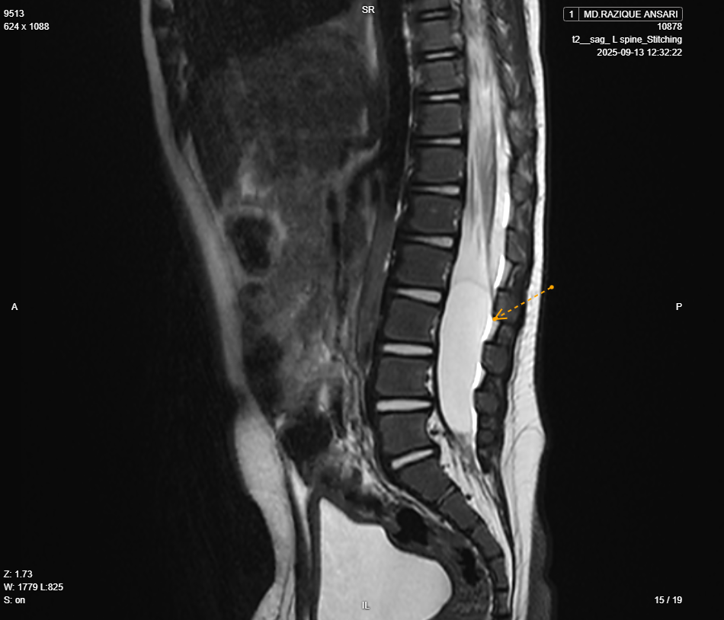  Image 1 | 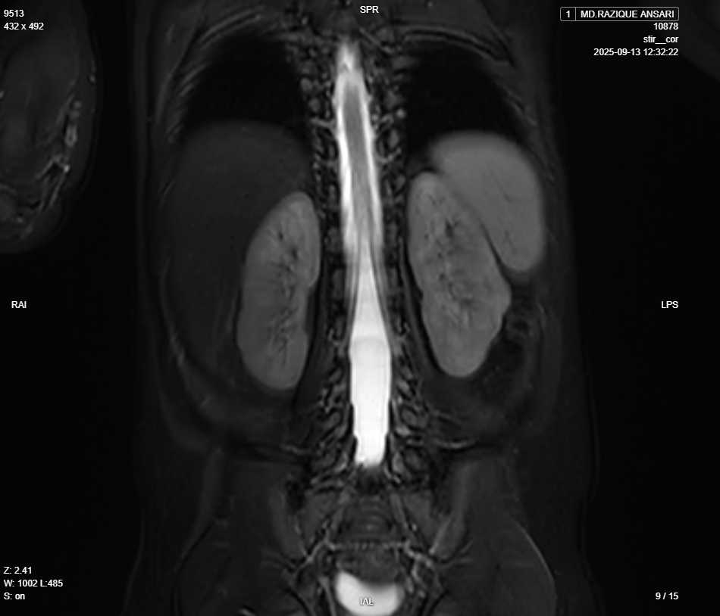  Image 2
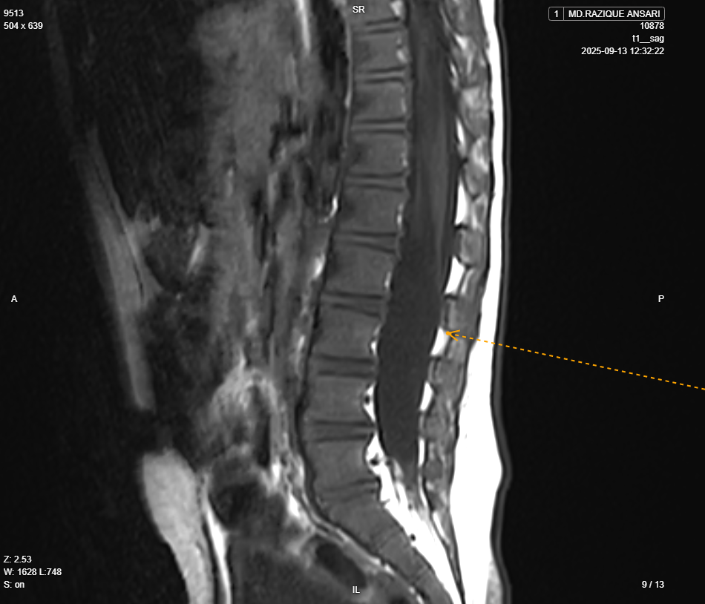  Image 3 | 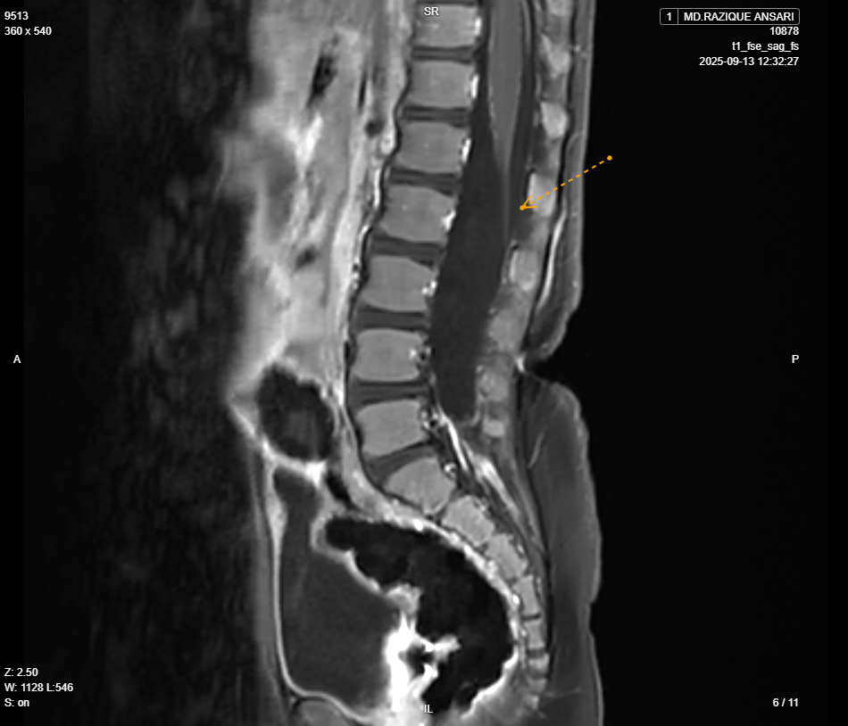  Image 4

Scan to know your report  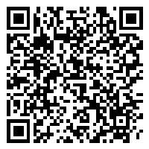  Bionic Report eXplainer | Verified By,  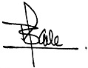  Dr. Kale Balaji Baliram  Consultant Radiologist  MMC - 2015/06/3398 | Reported By,  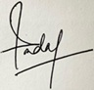  Dr. Sadaf Shahzad  MBBS, MD  Consultant Radiologist  JKMC - 15712  Series/Image: 30/434

Disclaimer
This medical diagnostic report is generated based on the image and patient information obtained from the source of origin, 5C Network assumes no responsibility for errors or omission of or in the image, or in the contents of the report, which are a direct interpretation of the image sent from source. In no event shall 5C Network be liable for any special, direct, indirect, consequential, or incidental damages or any damages whatsoever, whether in an action of negligence or other tort, arising out of or in connection with the use of the 5C Network Service or the contents of the Service. This report does not replace professional medical advice, additional diagnoses, or treatment.
Kindly call Help Desk (+91-95872 74858) for any report related query.
Powered by 5C Network. All Rights Reserved.


